Mental Health & Emotional Wellbeing Services and Resources for Professionals and Families

For urgent mental health help or if you need to urgently speak to someone
Call our Single Point of Access (SPA) Tel: 0300 777 0707 from 8am - 7pm.
Email: hpft.spa@nhs.net
Alternatively, call our Out of Hours Helpline Tel: 01438 843322. This service is available to our existing service users and carers, for advice and support outside office hours from 5pm-9am on weekdays and around the clock at weekends and on Bank Holidays.

We are including a link for a video which has been created by the World Health Organisation (WHO). This video talks about COVID-19 and mental health. In particular from timestamp 10.56 minutes the video provides advice for parents as to how to support conversations with their child about the virus: https://youtu.be/zDx1LKkk5c4

Available anytime (24/7)

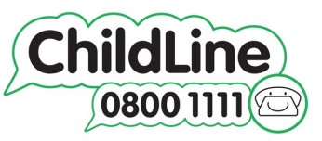
- ChildLine – call 0800 1111
Talk to a counsellor for free anytime by calling 0800 1111.
You can also log in for 1-2-1 chat or email (www.childline.org.uk/get-support)
- YoungMinds Crisis Messenger – Text “YM” to 85258
A free crisis messenger service support across the UK. If you are experiencing a mental health crisis and need support, you can text YM to 85258.

- Samaritans – call 116 123
Talk to a trained volunteer anytime for free non-judgemental support.
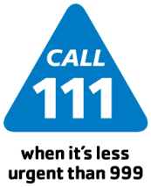
- NHS Direct – call 111
NHS Direct can help if you have an urgent medical problem and you’re not sure what to do.
- Accident & Emergency (A&E) at your local hospital.
If you feel you cannot keep yourself safe, it is best to attend your local A&E so they can help to keep you safe.

Further websites and helplines
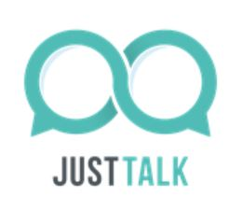
- Just Talk Herts website gives advice on looking after your mental health during coronavirus. https://www.justtalkherts.org/news/looking-after-your-mental-health-during-coronavirus.aspx
- Families First Portal supporting all Hertfordshire families https://www.hertfordshire.gov.uk/microsites/families-first/families-first.aspx
- Hertfordshire county council directory of services for families living in Hertfordshire: https://directory.hertfordshire.gov.uk/Categories/29

- http://www.annafreud.org/coronavirus
The Anna Freud National Centre for Children and Families is a children’s mental health charity. The above link provides information and advice for children and young people, parents/carers and
schools and colleges.

- www.kooth.com - A free, safe and anonymous online counselling service for young people aged 10-16. It provides support from qualified counsellors via mobile, tablet and desktop computer. Young people can access support directly without needing a referral.

- www.familylives.org.uk - An online parenting advice and support. Family Lives offers a confidential and free helpline service for families in England and Wales (previously known as Parentline). Please call 0808 800 2222 for emotional support, information, advice and
guidance on any aspect of parenting and family life. Helpline service is open 9am – 9pm Monday to Friday, and 10am – 3pm Saturday and Sunday.
Email contact: askus@familylives.org.uk

- www.youngminds.org.uk - Offers advice to parents and carers worried about a child or young person under 25. You may have questions about a child’s behaviour, emotional wellbeing, or mental health condition. You may have a child
who’s already been admitted to NHS Child Adolescent Mental Health Services (CAMHS) and have questions about their treatment or want to know what to say to your GP when you visit them. Parent Helpline: 0808 802 5544, Monday to Friday 9.30am – 4pm.
- www.sane.org.uk - SANE provides emotional support, guidance and information to anyone affected by mental illness, including families, friends and carers. Out of hours Sane helpline Tel: 0300 304 7000 from 4.30pm – 10.30pm every day.

- www.papyrus-uk.org – A charity dedicated to the prevention of young suicide with a specialist telephone service called HOPELINEUK, call
0800 068 41 41 or text 0778 6209697.
HOPELINEUK offers support, practical advice and
information to young people up to the age of 35
who are worried about how they are feeling or anyone who is concerned about a young person. Available Monday to Friday, 10am – 10pm;
Sat/Sun & bank holidays 2pm – 10pm.

Mental health apps

Beat Panic – Overcome panic attacks and anxiety wherever you happen to be

Big White Wall – Get round the clock support from therapists to help you cope with stress and anxiety

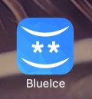
BlueIce – Helps young people manage their emotions and reduce urges to self-harm

Calm Harm – Helps reduce urges to self-harm and manage emotions in more positive way

Catch It – Learn to manage negative thoughts and look at problems differently.

Chill Panda – Use breathing techniques to help you relax more, worry less and feel better.

Cove – Create music to reflect emotions like joy, sadness and anger to help express how you feel.

DistrACT – Quick and discreet access to information and advice about self-harm and suicidal thoughts.

eQuoo: Emotional Fitness Game – Adventure games designed by psychologists to help you increase your emotional fitness.

Feeling Good: positive mind-set – Use audio tracks to help relax your body and mind and build you confidence.

Ieso – Connect confidentially and securely with mental health therapists using instant messaging.

MeeTwo – A safe and secure forum for teenagers wanting to discuss any issue affecting their lives.

My Possible Self: The Mental health App – Learn how to manage fear, anxiety and stress and tackle unhelpful thinking

SilverCloud – An eight-week course to help you manage stress, anxiety and depression at your own pace.

Sleepio – An online sleep improvement programme, clinically proven to help you fall asleep faster.

Sleepstation – Connect with a team of sleep experts to help you fall asleep or stay asleep through the night.

Stress & Anxiety Companion – Breathing exercises, relaxing music and games to help calm your mind and change negative thoughts.

Student Health App – Reduce your worries, feel more confident and get the health information you need as a student.

Thrive – Use games to track your mood and teach yourself methods to take control of stress and anxiety.

Headspace – A meditation and mindfulness app.

Happier – Helps you practice mindfulness, gratitude and a more positive outlook by learning to appreciate the small moments throughout your day.

